EURO 2016 SCHEDULE
KNOCK OUT STAGES
ROUND OF 16 |  |  |  | QUARTER FINALS |  |  |  | SEMI FINALS |  |  |  | FINAL
37 | 26-Jun, 4:00 |  |  |  |  |  |  |  |  |  |  |  | 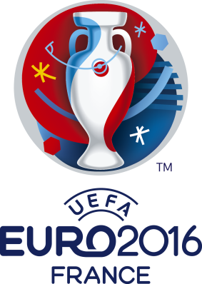
A2
C2
 | Stade Geoffroy Guichard |  |  | 45 | 1-Jul, 10:00
39 | 26-Jun, 10:00 |  |  |  | Stade Velodrome
D1
BEF33
 | Stade Bollaert-Delelis |  |  |  |  |  |  | 49 | 7-Jul, 10:00
38 | 26-Jun, 7:00 |  |  |  |  |  |  |  | Stade de Lyon
B1
ACD3
 | Parc des Princes |  |  | 46 | 2-Jul, 10:00
42 | 27-Jun, 10:00 |  |  |  | Stade Pierre Mauroy
F1
E2
 | Stadium de Toulouse |  |  |  |  |  |  |  |  |  |  | 51 | 11-Jul, 10:00
41 | 26-Jun, 18:00 |  |  |  |  |  |  |  |  |  |  |  | Stade de France
C1
ABF3
 | Stade Pierre Mauroy |  |  | 47 | 3-Jul, 10:00
43 | 28-Jun, 7:00 |  |  |  | Stade de Bordeaux
E1
D2
 | Stade de France |  |  |  |  |  |  | 50 | 8-Jul, 10:00
40 | 27-Jun, 4:00 |  |  |  |  |  |  |  | Stade Velodrome
A1
CDE3
 | Stade de Lyon |  |  | 48 | 4-Jul, 10:00
 |  |  |  |  |  |  |  |  |  |  | CHAMPION
44 | 28-Jun, 10:00 |  |  |  | Stade de France
B2 |  |  |  |  |  |  |  |  |  |  | COUNTRY
F2
 | Stade de Nice

